

February 8, 2018
HUD Cut-blanks
Equipment
Eastman HUD Cut-blanks
Equipment List

- Conveyor model 25-PVE24EZ. Manufactured in 2013 by Hytrol. See photos and specification drawing.

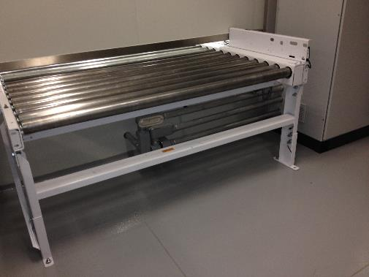
Picture 1a: Inlet conveyor

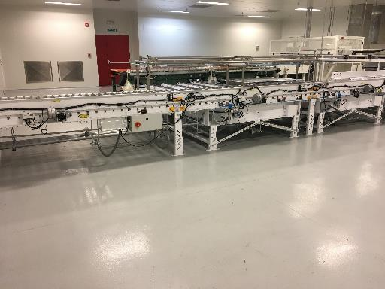
Picture 1b: Conveyor for plates


2

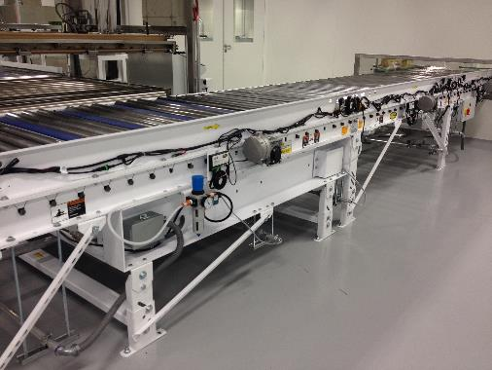
Picture 1c: Exit Conveyor

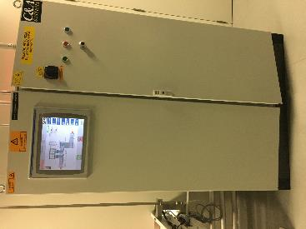
1d: Panel view Conveyor

1e: Machine manual available on purchase

3

- Unwinder and Cutting machine: Manufactured in 2013 by Rosenthal Manufacturing Co. Inc.

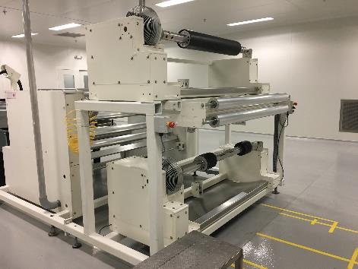
Picture 2a: Unwinder for 2 rolls, breakers, roll diameter measurement & accumulator for roll change

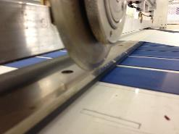
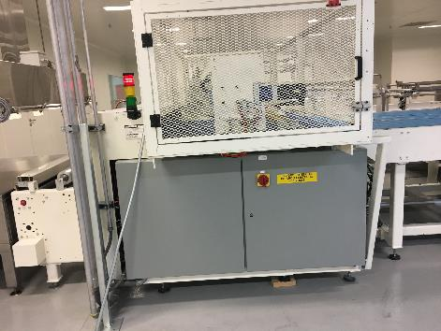

Picture 2b: Cutting machine with inlet accumulator.
Knife with movement for maximum +/- 10 degrees cut angle

4

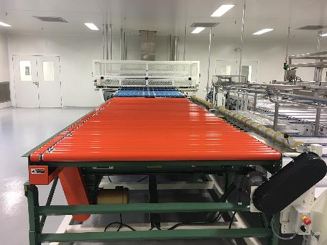
Picture 2c: Exit conveyors to send out blanks

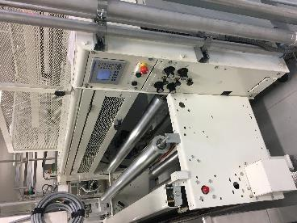

Picture 2d: Panel view for unwinder & cutting machine Picture 2e: Machine manual available on purchase

5
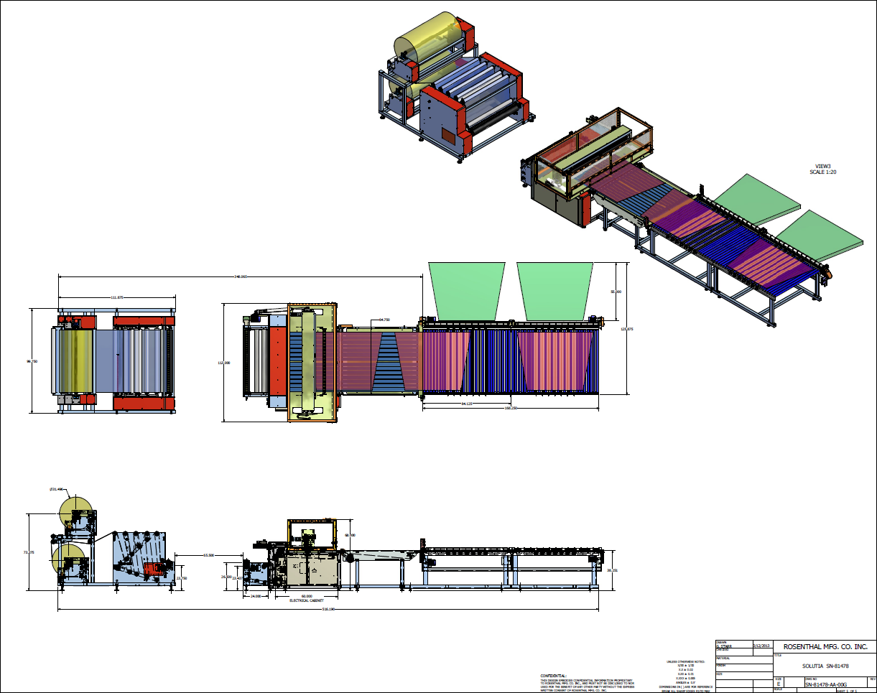
Picture 2f: Actual drawing will be provided in response to serious interest.
6

- Conveyor Oven (stainless steel construction): Manufactured in 2013 by INTEK Corporation.

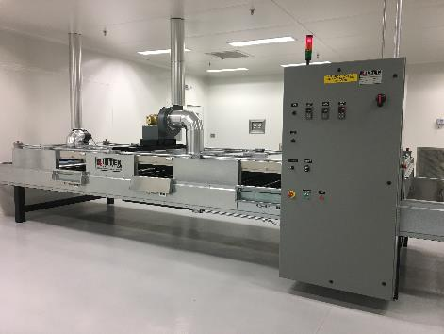
Picture 3a: Oven with safety doors, and temperature control panel.
Total Connected Load: 154 Kw, 480 V, 3 Ph, 60 Hz.

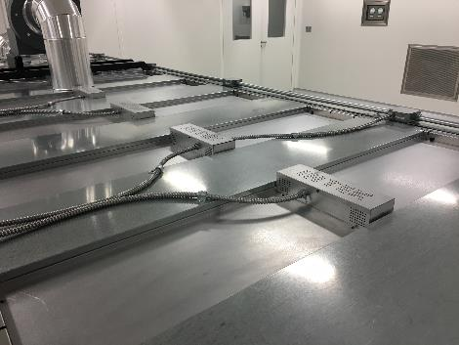
Picture 3b: Multizone heat control:
2 heat controls - 3 heat zones, wavelength 3.4 microns approximately 1,100°F (593°C).

7

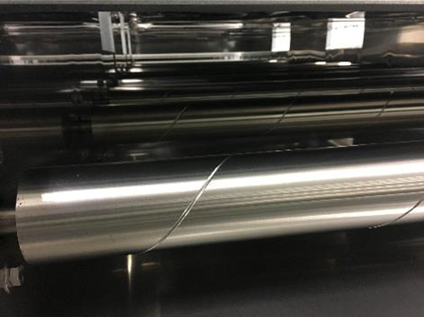
Picture 3c: Steel roller conveyor with VFD control,
adjustable from 16.25 fpm (5 m/min) to 65.6 fpm (20 m/min).

8
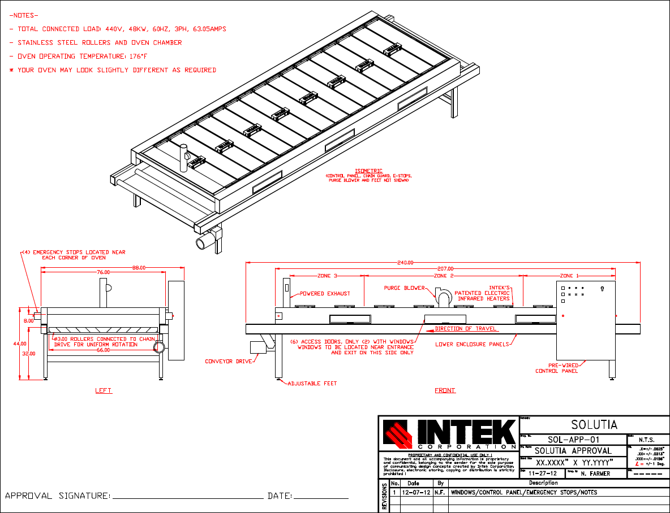
Picture 3d: Drawing for Windows/Control Panel/Emergency stops.
9

10
Picture 3e: Solutia Oven Control Address

Approximate oven dimensions

Internal oven chamber:
68” (1727mm) width
207” (5258mm) length
8” (203mm) height

Overall external dimensions

88” (2439mm) width (includes control panel)
240” (6096mm) length, including conveyor
72” (1525mm) height (includes purge and exhaust blowers)
- Cooling table and End conveyor: Stainless steel cooling table. End conveyor is stainless steel and carbon steel construction. Manufactured in 2013 by EOLIS & Norte.

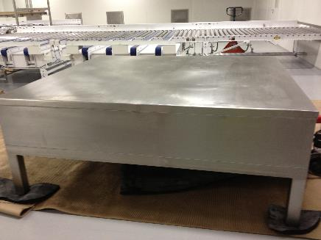
Picture 4a: Cooling table. Table is cooled with Chiller water.
Used for cooling down the PVB sheet after it’s gone through the oven.

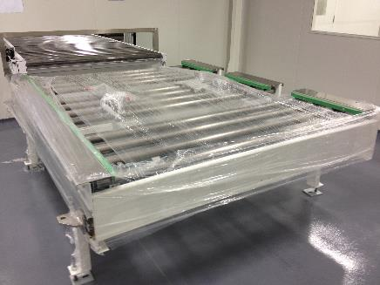
Picture 4b: End Conveyor with position detectors and VFD.
Equipment is used to enable transfer of HUD Cut-blanks to Pallet using a Lift Truck.
11

For more information, please contact your TS/AD Lead or Account Manager.

